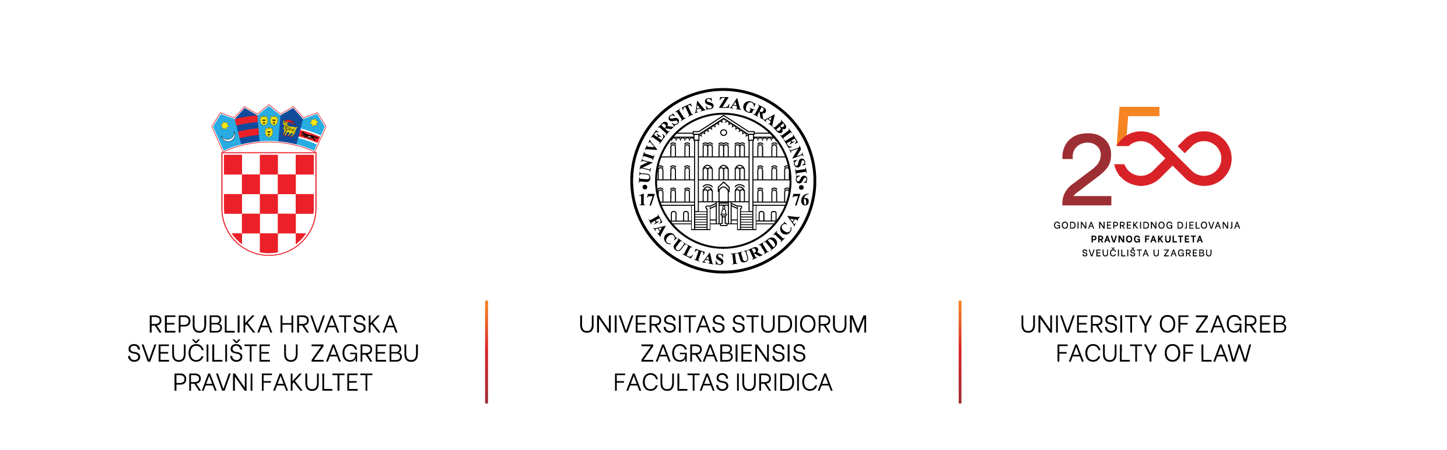

Call for Students and Researchers for
Voluntary Participation in the Project
"Conflicts between Norms and Traditional Criteria for Their Resolution in Modern Legal Systems" (NextGenerationEU Project)
We invite interested students, particularly those in advanced years of study, as well as young researchers, to apply for participation in scientific research within the framework of the above-mentioned project, financed from the European Union's NextGenerationEU.( IIP-SINTrak-25-28)
Participation is as an external collaborator based on a voluntary agreement.
Benefits of participation:
- Certificate of participation in project activities;
- Acknowledgment as a collaborator in all publications produced during the project
- Participation in conferences organized within the project;
- Possibility of co-financing participation in conferences, depending on available funds;
- Opportunity to continue scientific work under the mentorship of project team members.
Job description:
- Collecting, categorizing, and storing relevant publications published between 1 January 2022 and 31 December 2024;
- Collecting, categorizing, and storing publications of relevant scholars published between 1 January 2000 and 31 December 2025;
- Identifying and recording relevant data from the collected publications;
- Participation in project scientific conferences.
Requirements:
- Students of law faculties and young researchers;
- Proficiency in one of the following languages: Croatian, Spanish, or Italian;
Advantage in selection process: completion of a course in legal theory, participation in scientific conferences (especially in legal theory).
Applications with a motivation letter and CV (in Croatian, Spanish, Italian or English) should be sent by 1 March 2026 to the email: mdelgadonieves@pravo.hr.
